

**LAB MANUAL**

**Computer organization**

**&**

**Assembly language (AL)**

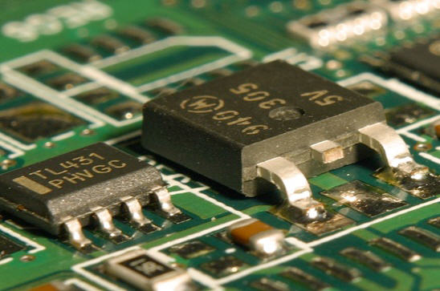

**Lab 01:**

**Introduction TO Assembly language(AL)**

**&**

**First AL Program**

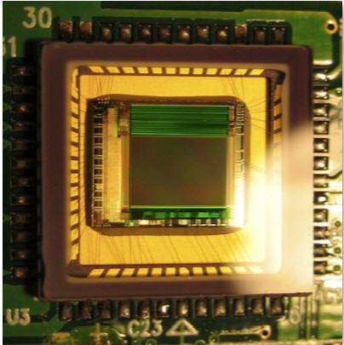

**Lab 01:**

**Pre-Lab:**

A basic overview of architecture for Intel based microprocessor’s (discussed in class lecture earlier) and hands-on experience of any high level language is a basic pre-requisite for all COA labs.

**Goal:**

To introduce students about assembly language (AL) syntax to help develop their first assembly language (AL) program. Furthermore, lab is designed to run your first AL program using command line prompt.

1. Understanding and assembling first program in AL**.**
2. Learn to assemble and execute using DOS command line interface.

**Target of Lab 01:**

* **Introduction to assembly language (AL).**
* **Introduction to editor, assembler, debugger and linker.**
* **First AL program execution.**
* **File types generated during assembling and executing program.**
* **Assemble-link-execute cycle**



**Lab Tasks:**

* Go through all the stuff pertaining to AL programming presented in class lecture. Make notes and try to learn the basics of every instruction used in AL program.
* Refer to text book ***Assembly language for x86 processors by kip Irvine*** and read chapter 3 in depth.
* Refer to lecture slides for guided study aid.

**Assembling and executing your first aL program in DOS (command Prompt):**

**Software required*:**

* **MASM 6.15 (Assembler)**
* **32-bit operating systems(Windows)**
* **DOS interface (command prompt)**
* **Welcome.asm program (shared on group)**

*\*All these stuff are available on group as well in class*

**Procedure:**

Let's assume that you have MASM 6.15 and sample program ***(welcome.asm)*** at hand, and then follow steps carefully for lab 01 completion.

**Step 1**

Unzip Masm 6.15 to following preferable directory **C:\Masm615** directory. If you decide to use a different path, you'll have to modify some of the batch files we use for assembling, linking, and debugging (*not preferred at this point*).

**Step 2**

Create a directory/folder on your hard drive where you would like to save your work. We will call this your **working directory** from now onwards. For Example, create a folder and name it asmCodes like **C:\asmCodes**

* Look for the *make32.bat* file in the C:\Masm615 directory. Copy it to your working directory C:\asmCodes
* Look for the welcome*.asm* program provided by instructor available on group, copy it to your working directory.
* Open a DOS/command prompt window. Do this by selecting **Run** from the **Start** menu, and run **cmd.exe**. (If that doesn't work, try running **command.com** instead.)
* At the command prompt, move to your working directory C**:\asmCodes**,following commands will be helpful for you,

|  |
| --- |
| **cd/ move to root directory**  **cd <dirName> change current directory to specified directory** |

**Demo Example:**

Demo example on my PC will be helpful in doing it.

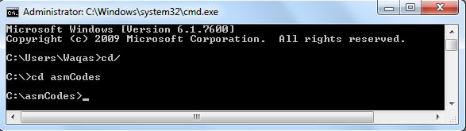

Change to ur required directory

Select root directory

**Step 3: Assembling and linking**

After moving to your work directory. Type the following command to assemble and link your first program:

|  |
| --- |
| C**:\asmCodes> make32 welcome.asm** |

(Cautions: Program names and filenames are not case-sensitive at the command prompt. If you got an error shown below after exactly typing above command.i.e. 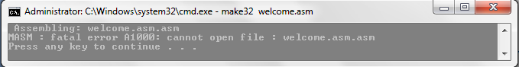

Try above command without .asm extension i.e. *C****:\asmCodes> make32 welcome***

You should see the following output screen. It shows the execution of the Microsoft Assembler, the Linker, and lists all filenames in the current directory beginning with "*welcome*":

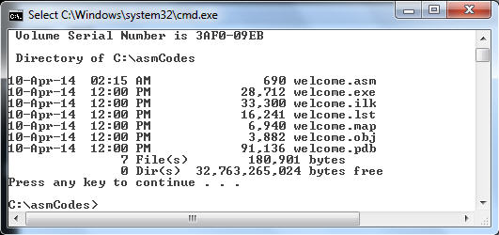

(Intentionally, I have changed the default black background of ***cmd*** for personal convenience.)

**Step 4: Executing Program**

The file **welcome.exe** is called the *executable program*. Run this program by typing welcome at the command prompt.

C**:\asmCodes> welcome**

**Output:**You should see the following output:

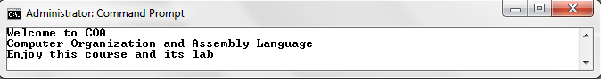

If you received welcome message on screen, hats off you done it in first run, Bravo, Thumbs up ☺ .

**The program in notepad:**

This is a screen snapshot of the Notepad editor, containing the ***welcome.asm*** program explained in class lecture or lab in detail:

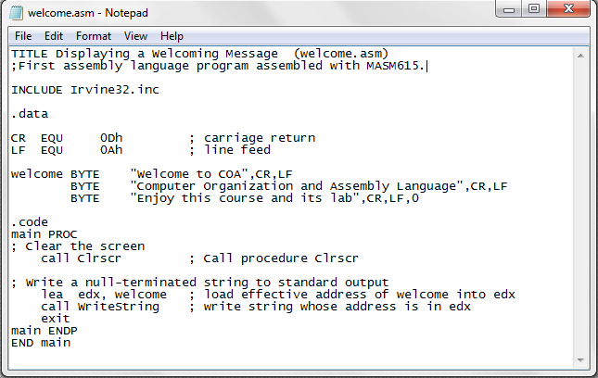

**Notes / Comments :**